**Data Visualisation Assignment**

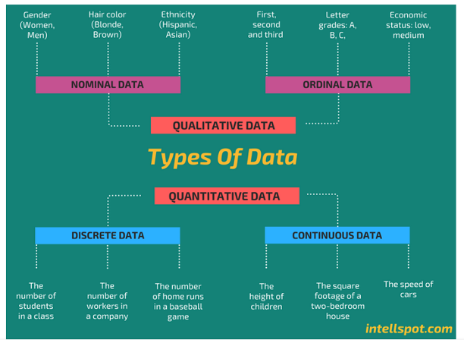

Arnold Mavunga

05.04.2024

Data - wave 5 - Cohort 1 - 18.03.2024

# **INTRODUCTION**

This report has been prepared to demonstrate the preparer’s understanding of data and data structures, development of data sets using Microsoft Excel and Tableau.

In completing the above, the report will also outline the policies and procedures which need to be adhered to when working with data, why the policies and procedures need to be adhered to and why this is important for a data analyst.

# 

# 

# 

# 

# 

# 

# 

# 

# **TABLE OF CONTENTS**

INTRODUCTION 1

TABLE OF CONTENTS 2

POLICIES AND PROCEDURES (when working with data) 3

What the policies are 3

Why the policies are important 4

How does this impact a data analyst 5

DATA STORY TELLING: EXCEL 6

DATA STORY TELLING: TABLEAU 21

REFLECTION 21

REFERENCES 22

# 

# 

# 

# 

# 

# 

# 

# 

# **POLICIES AND PROCEDURES (when working with data)**

## 

## **What the policies are**

Data Protection Policy: This policy outlines how data should be collected, stored, processed, and shared within an organization. It should cover aspects such as data access controls, encryption methods, and data retention periods.

Privacy Policy: A privacy policy informs individuals about how their personal data is collected, used, and protected by an organization. It should be transparent and easily understandable, complying with relevant privacy regulations such as GDPR (General Data Protection Regulation) in Europe

Data Security Policy: This policy defines measures to safeguard data against unauthorized access, disclosure, alteration, and destruction. It includes protocols for data encryption, access controls, authentication mechanisms, and regular security audits.

Data Retention Policy: This policy specifies the duration for which different types of data will be retained by an organization. It ensures that data is not kept longer than necessary and is disposed of securely when it's no longer needed.

Data Governance Policy: Data governance policies establish frameworks for managing data assets effectively across an organization. They cover data quality standards, metadata management, data ownership, and compliance with regulatory requirements.

Data Handling and Processing Policy: This policy outlines procedures for handling data throughout its lifecycle, from collection to disposal. It includes guidelines for data entry, processing, analysis, and sharing, emphasizing the importance of accuracy, integrity, and confidentiality.

Data Access and Usage Policy: This policy defines who within an organization has access to different types of data and under what circumstances. It also outlines permissible uses of data and restrictions on data sharing to prevent misuse or unauthorized disclosure.

Compliance Policies: Organizations must comply with relevant regulations and standards governing data protection and privacy, such as GDPR, HIPAA (Health Insurance Portability and Accountability Act), or PCI DSS (Payment Card Industry Data Security Standard). Compliance policies ensure adherence to these requirements and mitigate legal and regulatory risks.

Training and Awareness Programs: Regular training and awareness programs are essential to educate employees about data policies, procedures, and best practices. These programs help foster a culture of data security and privacy within the organization.

Incident Response Plan: In the event of a data breach or security incident, organizations should have a well-defined incident response plan in place. This plan outlines steps for containing the breach, mitigating its impact, notifying affected parties, and cooperating with relevant authorities.

(Information from the European Commissioner, California Legislative Infromation, ISO and Information Security Forum - see references)

## **Why the policies are important**

Data protection policies are important for the following reasons:

They are a fundamental right protected by law

Data protection is a right that is protected by the EU Charter of fundamental rights. Additionally, since the General Data Protection Regulation (GDPR) came into force in May 2018, organizations must ensure that individuals’ data is adequately protected by certain procedures within its regulation.

They help to build trust

Individuals are increasingly aware of their right to privacy and their right to protection of their pers. Mismanagement of data can quickly damage the reputation of an organisation and undermine the trust individuals may have had. Because of this, organisations which demonstrate good compliance with data protection policies and legislation are more likely to build trust amongst its users or customers.

They prevent fraud and cyber crimes

Applying strong data protection measures protects individuals' data, customer data and organisational data.

They save time and money

Dealing with the aftermath of a data breach can be costly and time-consuming. Fines may need to be paid to individuals affected and to governing authorities. For example failure to comply with GDPR leading to a data breach may cost an organisation 4% of its annual turnover in the most extreme cases.

https://www.edpb.europa.eu/sme-data-protection-guide/data-protection-benefits-for-you_en#:~:text=It%20prevents%20fraud%20and%20cybercrimes,or%20your%20organisations'%20confidential%20information. (European Data Protection Board)

## **How does this impact a data analyst**

Data Analysts collect, organise and study data in order to provide insight to business functions and performance, ultimately using to this to enact improvements . Therefore it is important that data analysts follow data protection policy, rules and legislation of the organisation they work in and that of broader legislative bodies that issue laws on data protection, such as the information Commissioner’s office (ICO) in the UK and the European Data Protection Board. Failure to do so can lead to criminal proceedings that can result in fines levied upon the data analyst and the organisation the data analyst works for.

# 

# 

# 

# 

# DATA STORY TELLING: EXCEL

1. Setting a password to protect the **worksheet**

The computer at use is a Macbook Air, therefore the JustIT license for Microsoft Office 365 offered to candidates on the bootcamp does not allow the full functionality of desktop Microsoft Excel. Therefore the candidate has to make use of the web-version of Office 365 to access Microsoft Excel. The issue with the web-version of Microsoft Excel is it does not allow the protection of a whole Workbook. Therefore the example shown here will be the protection of a Work sheet. Screen shows have been supplied below.

Example of inaccessibility to desktop Microsoft Excel due to the licence type provided by JustIT and the computer in use by candidate 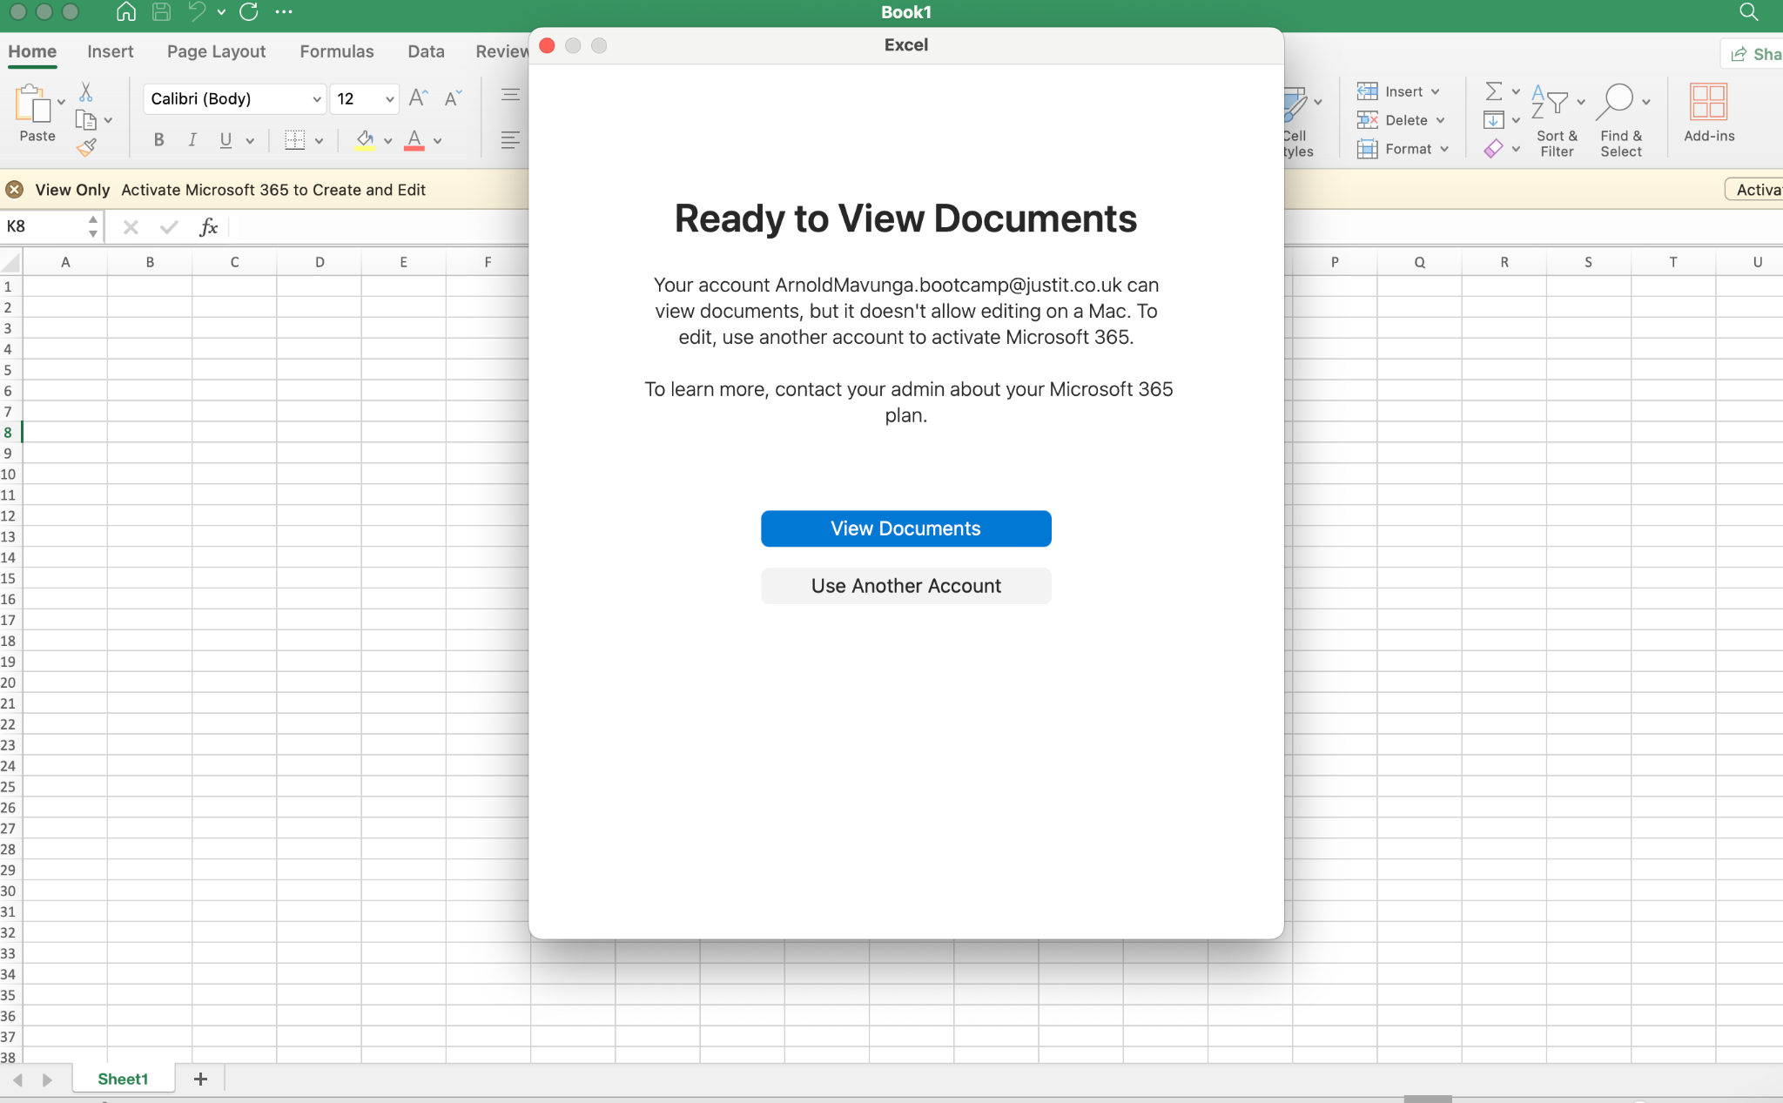

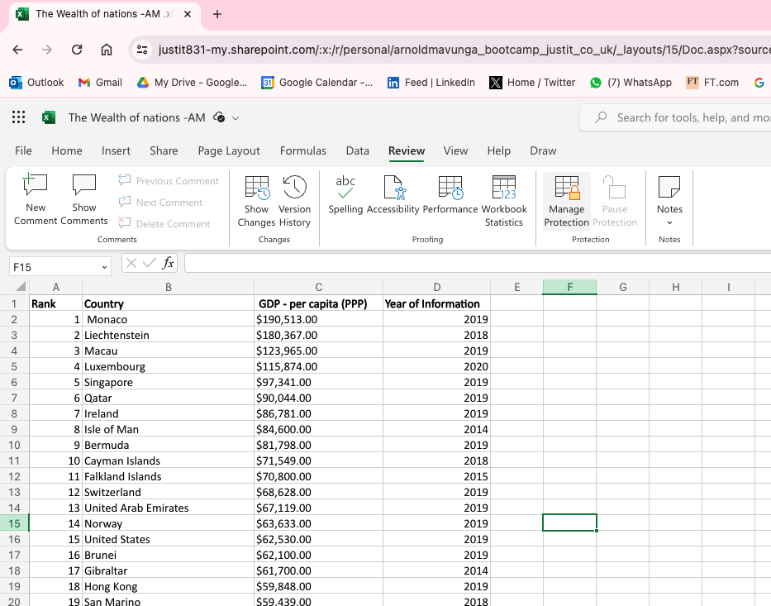

Selection of the manage protection through the review ribbon at the topic of Excel Online

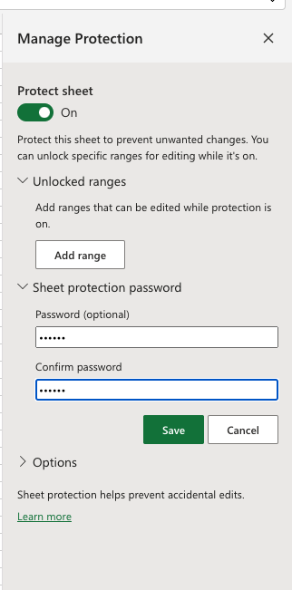

Password chosen for worksheet protection

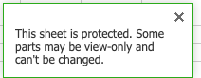



Worksheet is now locked

1. Highlight column C and change the data to display in British Pound symbo

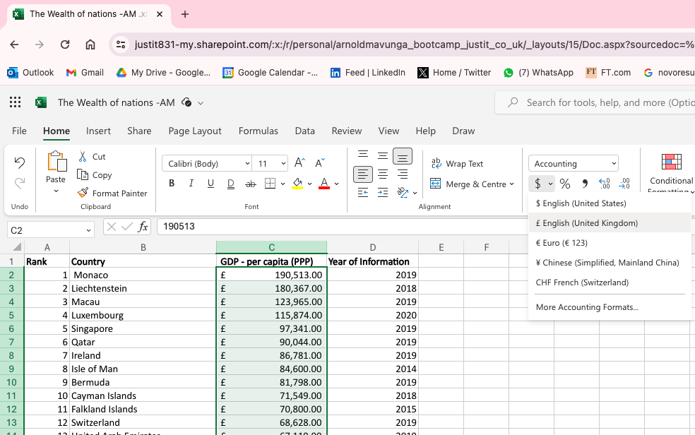

1. Turn the GDP sheet into a table.

# 

1. Filter the table to display only the information for 2019

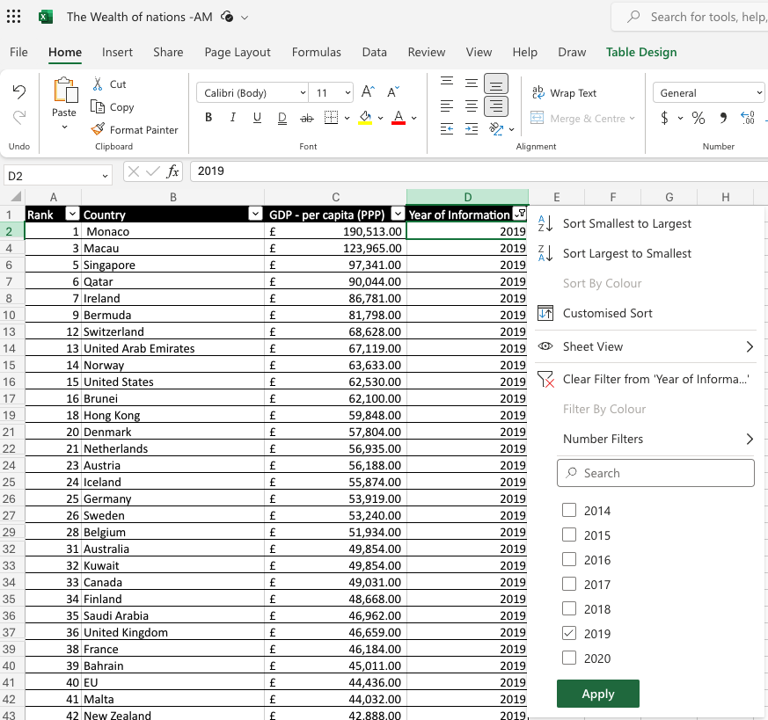

# 

# 

1. Next create a chart that will only display the following data ‘Rank, Country and GDP - per capita (PPP). The chart can be anything as long as it is suitable.

# 

1. Using your creative skills edit the chart a. Add a title

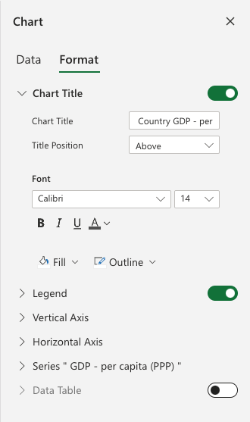

Change of the title to “Country GDP - per capita (PPP)”

* 1. Add X and Y axis labels

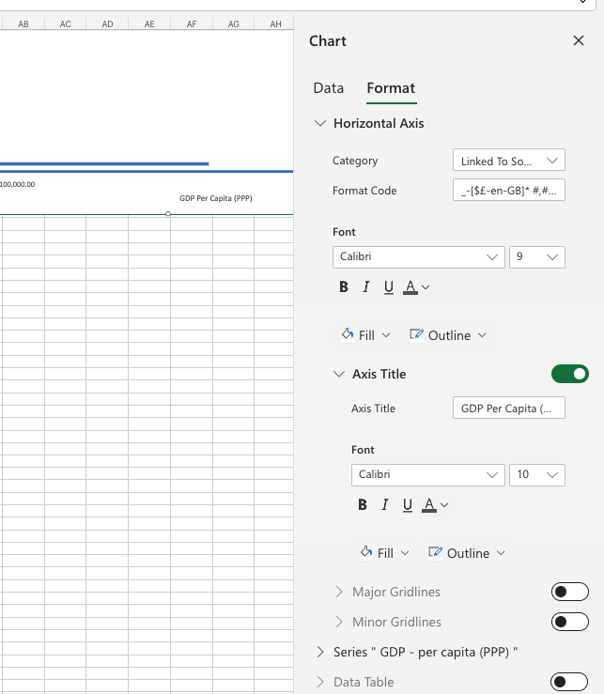

* 1. Make the chart visually pleasing

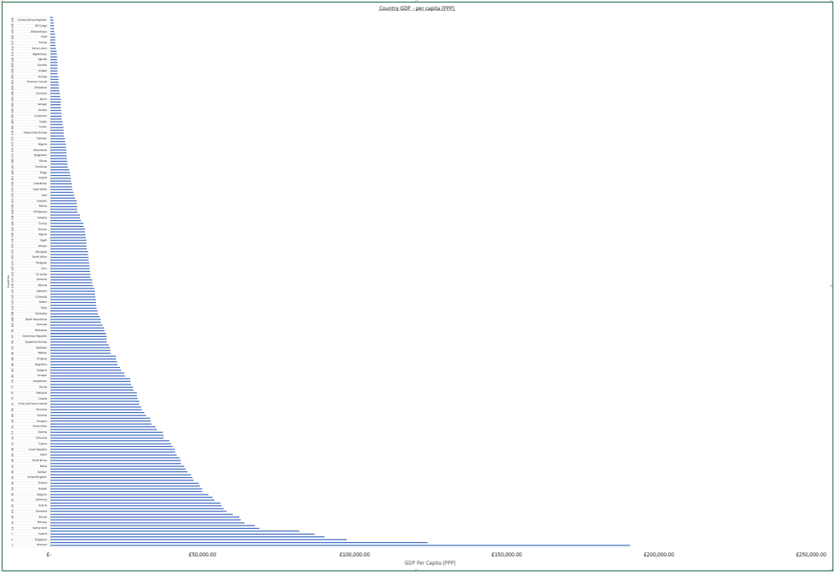

1. Move the chart to a new sheet tab and label with a suitable name

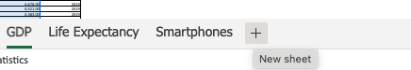

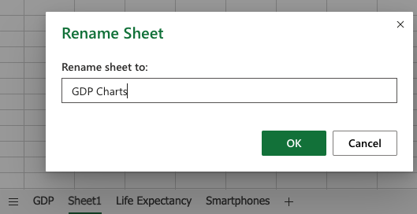

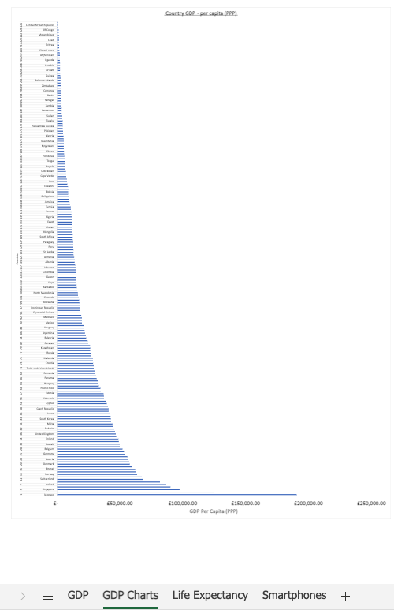

1. Create a sort for the top 20 highest ranking counties

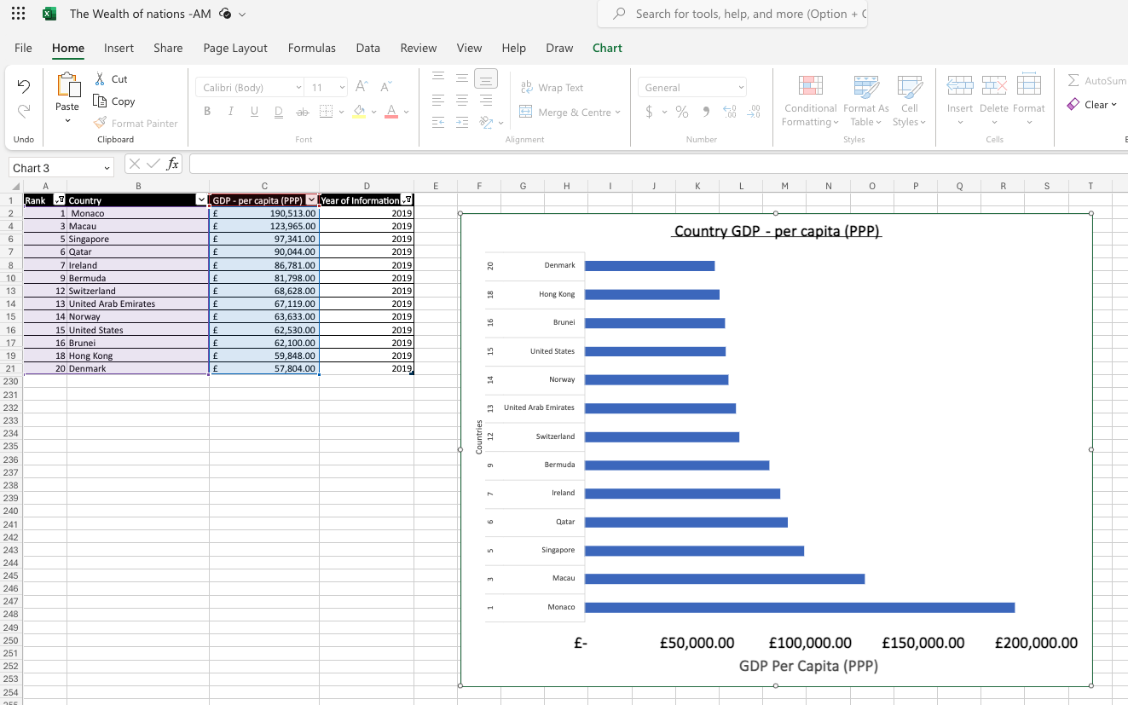

1. Next create a new Bar chart to display the 20 highest ranking countries from your sort and then move the chart to be underneath the table, as shown below.

# 

# 

# 

# 

# 

# 

# 

# 

# 

# 

# 

# 

# 

# 

1. Colour the background by highlighting the area underneath the table as shown below. Find the add a fill colour icon and select a colour.

# 

# 

# 

# 

# DATA STORY TELLING: TABLEAU

1. Import data

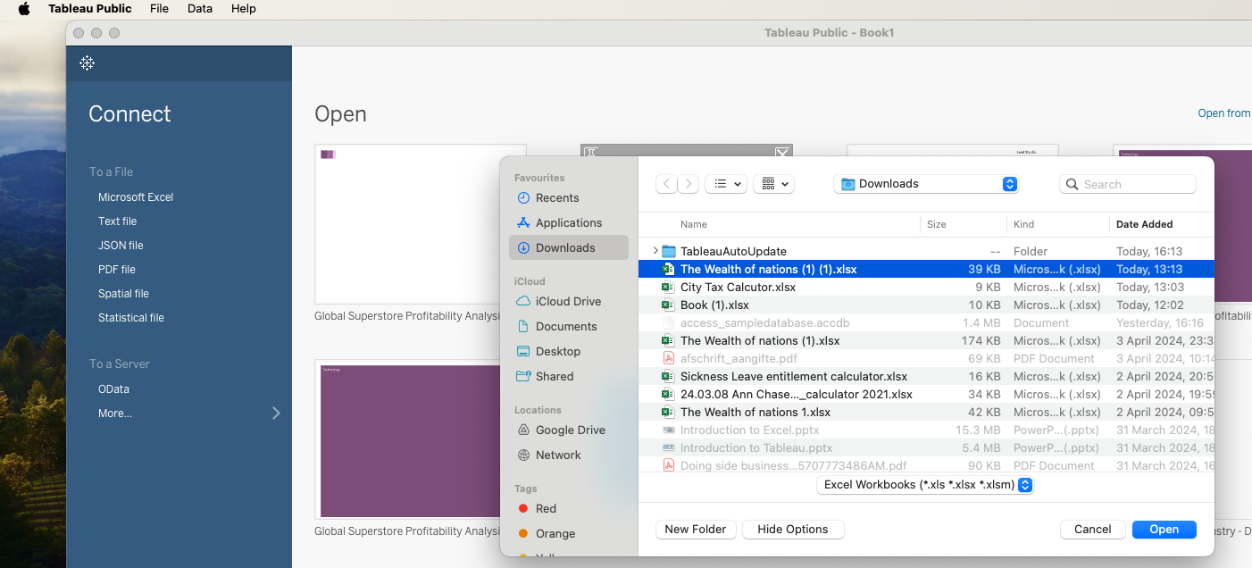

1. Set relationships

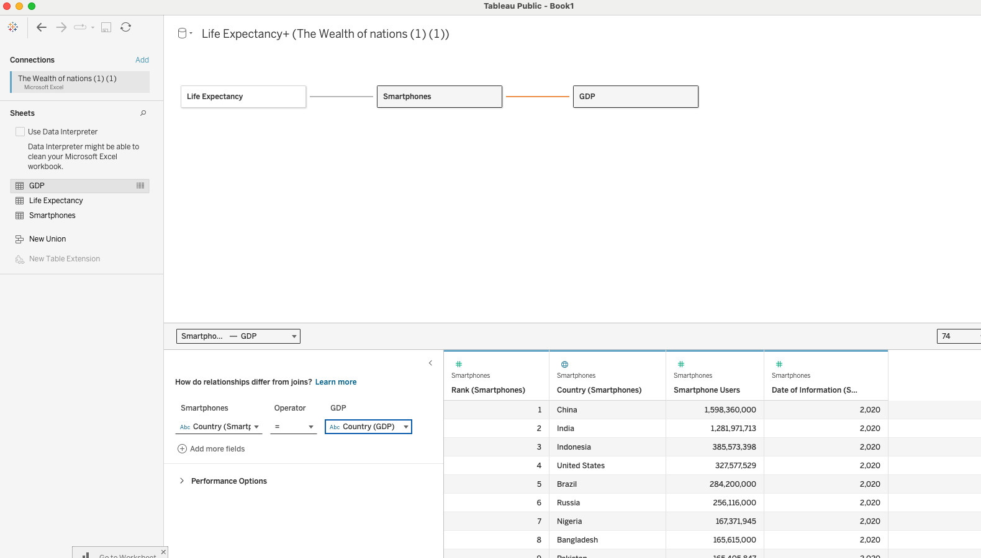

1. Check data types

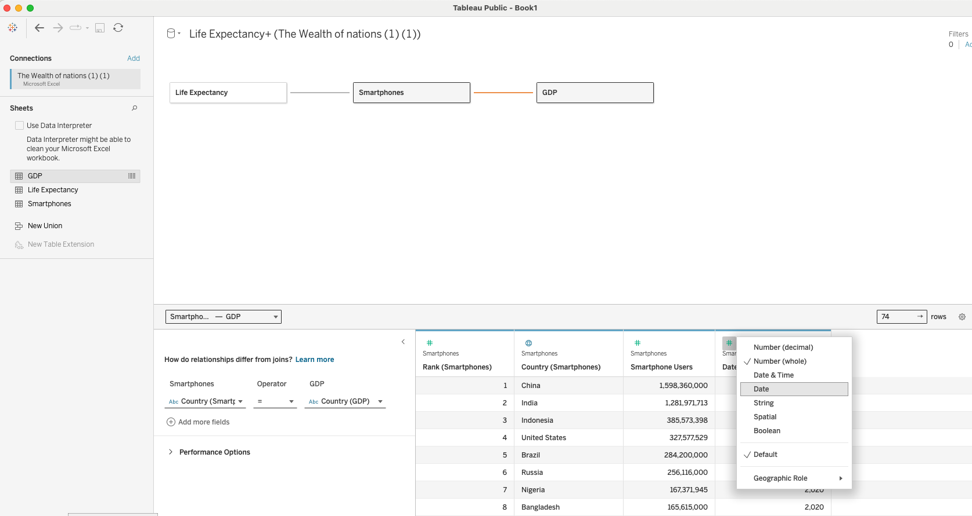

# 

# 

# 

# 

# 

Changing the date of information column to date for the smartphones table. Also completed for GDP table.

1. Build charts

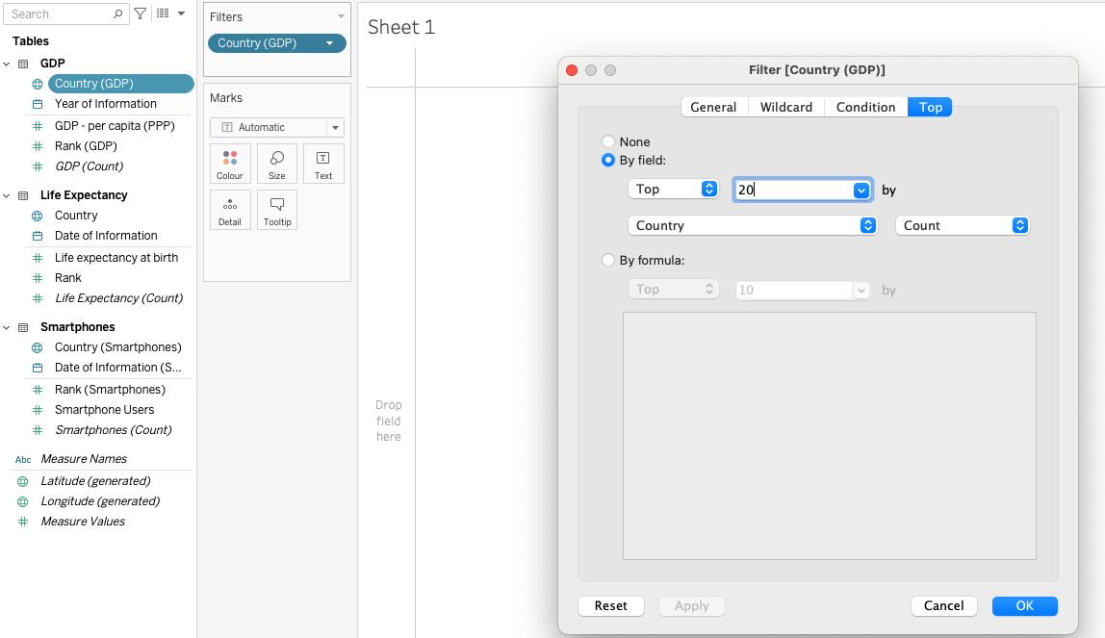

Filter on top 20 to meet client needs

# 

Created a packed bubbles chart to show life expectancy at birth by country (top 20)

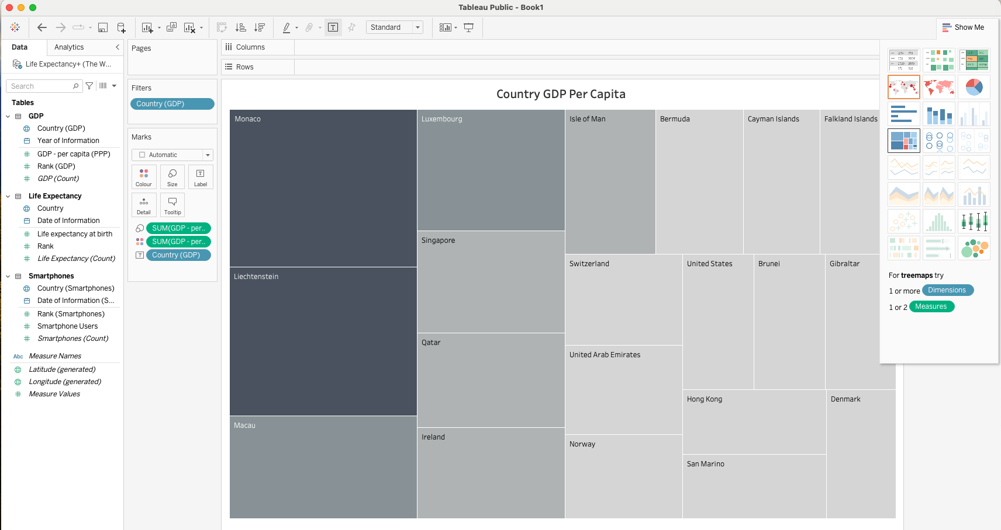

Created a treemaps chart to show top 20 country GDP per Capita

# 

Country by smartphone users

# 

Country map for smartphone users and life expectancy

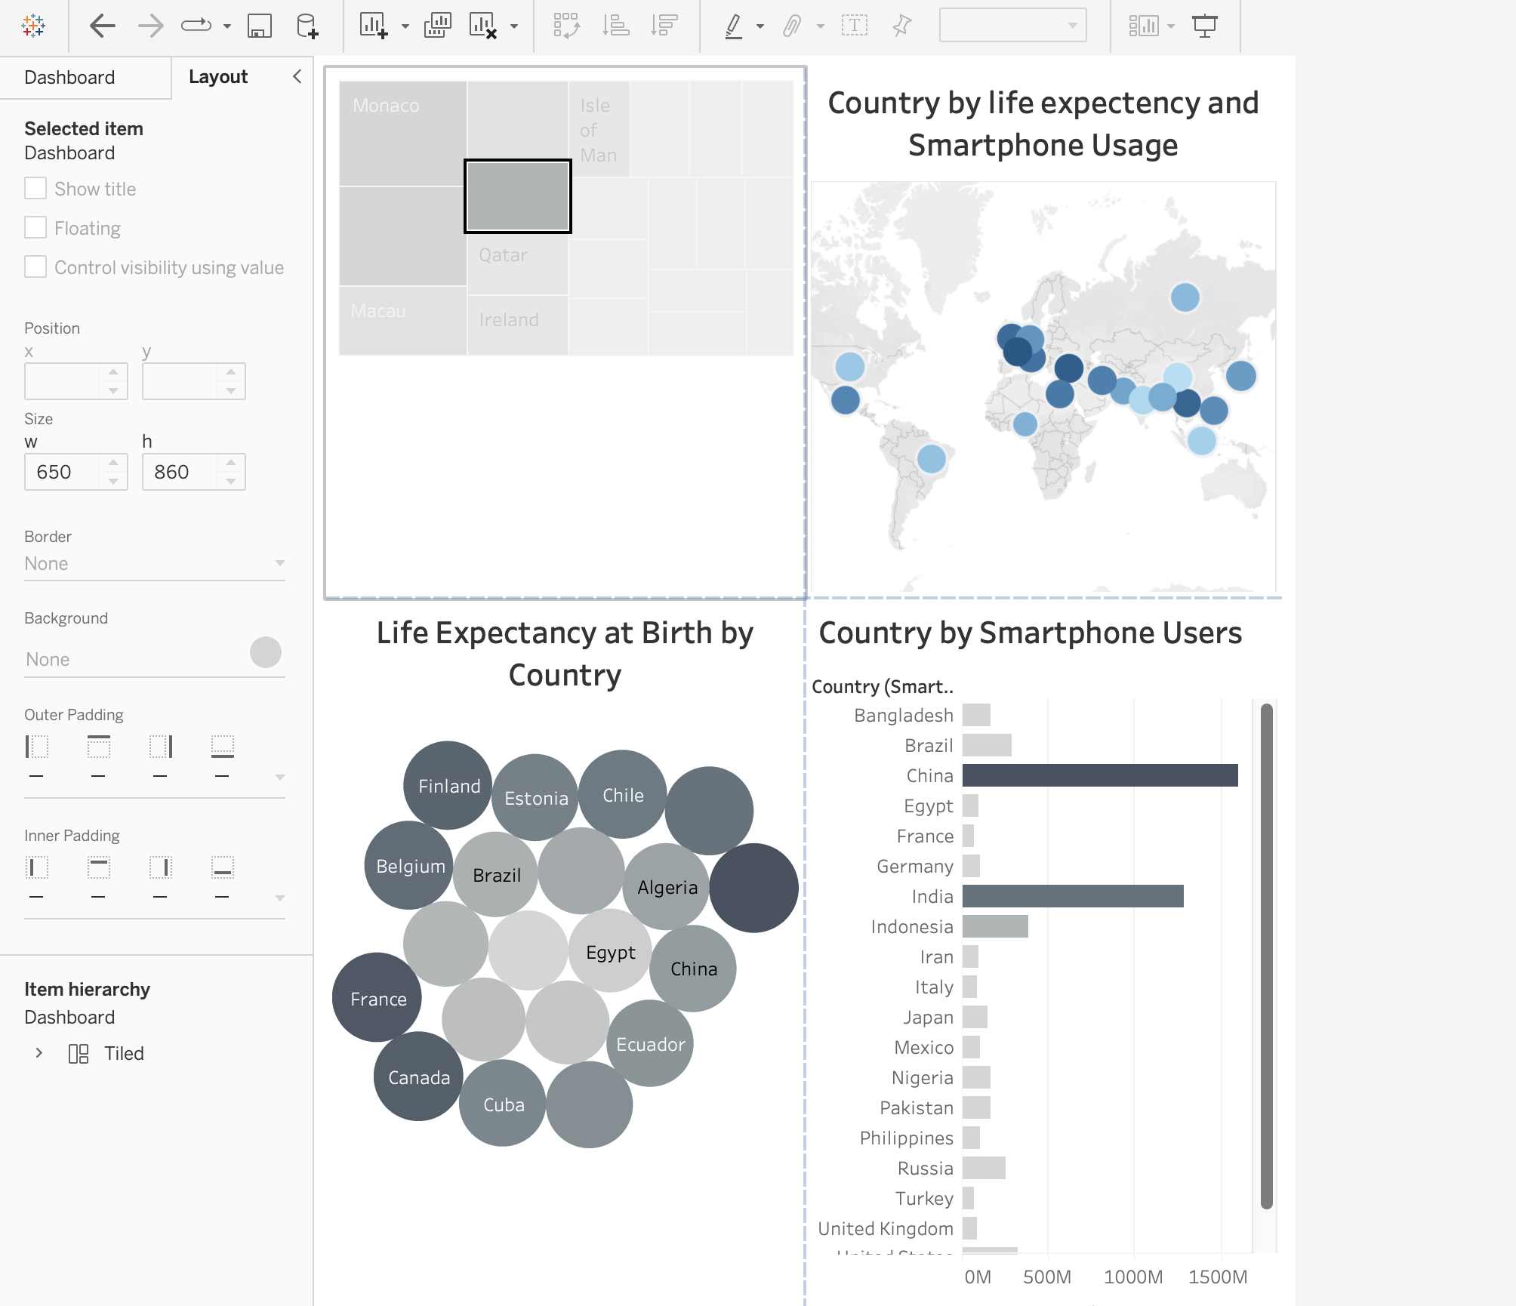

Dashboard completed

# 

# 

# REFLECTION

The project was effective in outlining the importance of data protection policies and the Use of Excel in manipulating data sets. The client being colour blind caused a challenge in the formatting of the data sets however it is still possible to achieve a good result.

# REFERENCES

1. [European Commission - GDPR](https://ec.europa.eu/info/law/law-topic/data-protection_en)
2. California Legislative Information - CCPA
3. U.S. Department of Health & Human Services - HIPAA
4. [PCI Security Standards Council - PCI DSS](https://www.pcisecuritystandards.org/)
5. ISO - ISO/IEC 27001
6. [NIST - NIST Special Publications](https://www.nist.gov/publications/search?f%5B0%5D=field_publication_type%3A1746)
7. [Information Governance Initiative](https://iginitiative.com/)
8. [Information Security Forum - Standard of Good Practice](https://www.securityforum.org/)
9. Center for Internet Security - CIS Controls
10. International Association of Privacy Professionals - CIPP
11. International Information System Security Certification Consortium - CISSP
12. (<https://www.justit.co.uk/employers/hire-an-apprentice/data-analyst/#:~:text=Data%20Analysts%20collect%2C%20organise%20and,to%20this%20to%20enact%20improvements>.)